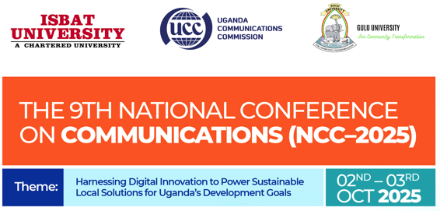

**Note for Authors**

**Manuscript Submission Guidelines**

**Submitting your research**

Researchers and students may submit their manuscript for the review process. The selected research articles will be published in the International Journal of Business, Engineering, Science & Technology (IJBEST) – An ISBAT University Journal disseminates high-quality research globally, and we are committed to diversity and inclusion in publishing. We encourage submissions and peer review from a diverse range of authors and reviewers from across all countries and backgrounds.

**Format of articles**

IJBEST publishes original research. In most cases, we do not impose strict limits on word count or page number. However, we strongly recommend that you write concisely and stick to the following guidelines:

* Articles should ideally be no more than 15 typeset pages
* The main text should be no more than 5,500 words (not including Abstract, Methods, References and figure legends)
* The title should be no more than 20 words, should describe the main message of the article using a single scientifically accurate sentence, and should not contain puns or idioms
* The abstract should be no more than 250 words

**Abstract**

Please do not include any references in your Abstract. Make sure it serves both as a general introduction to the topic and as a brief, non-technical summary of the main results and their implications. Abstract should be unstructured, i.e. should not contain sections or subheadings. Maximum in 250 words.

**Keywords**

We allow the use of up to 6 keywords/key phrases that can be used for indexing purposes. These should represent the main content of the submission.

**Manuscript**

Your manuscript text file should start with a title page that shows author affiliations and contact information, identifying the corresponding author with an asterisk. We recommend that each section includes an introduction of referenced text that expands on the background of the work. Some overlap with the Abstract is acceptable.

For the main body of the text, there are no specific requirements. You can organize it in a way that best suits your research. However, the following structure will be suitable in many cases:

* Introduction
* Review Analysis & Methods
* Results
* Discussion

You should then follow the main body of text with:

* References (limited to 60 references, though not strictly enforced)
* Acknowledgements (optional)
* Author contributions
* Data availability statement (mandatory)
* Tables (maximum size of one page)
* Please note, footnotes should not be used.

The manuscript can be submitted in the template format, specified for IJBEST Journal on this website.

Note:🡪

1. The researcher(s) will be sole responsible to ensure that their submitted work is originally developed/research by him/her/them.
2. Ensure your manuscript in into the specified format.
3. The research papers/published submitted for this prestigious conference, can be utilized/published by the International Journal for Business, Engineering, Science & Technology (IJBEST) considering the quality of research work by its peer review committee.
4. Acceptance of a research manual is not a guarantee of publishing the research paper in the IJBEST journal.